ME: This is my daily/morning routine. Can you find me a good app that will help me keep on track so I can see my routine at a glance and where I should be and what’s up next.
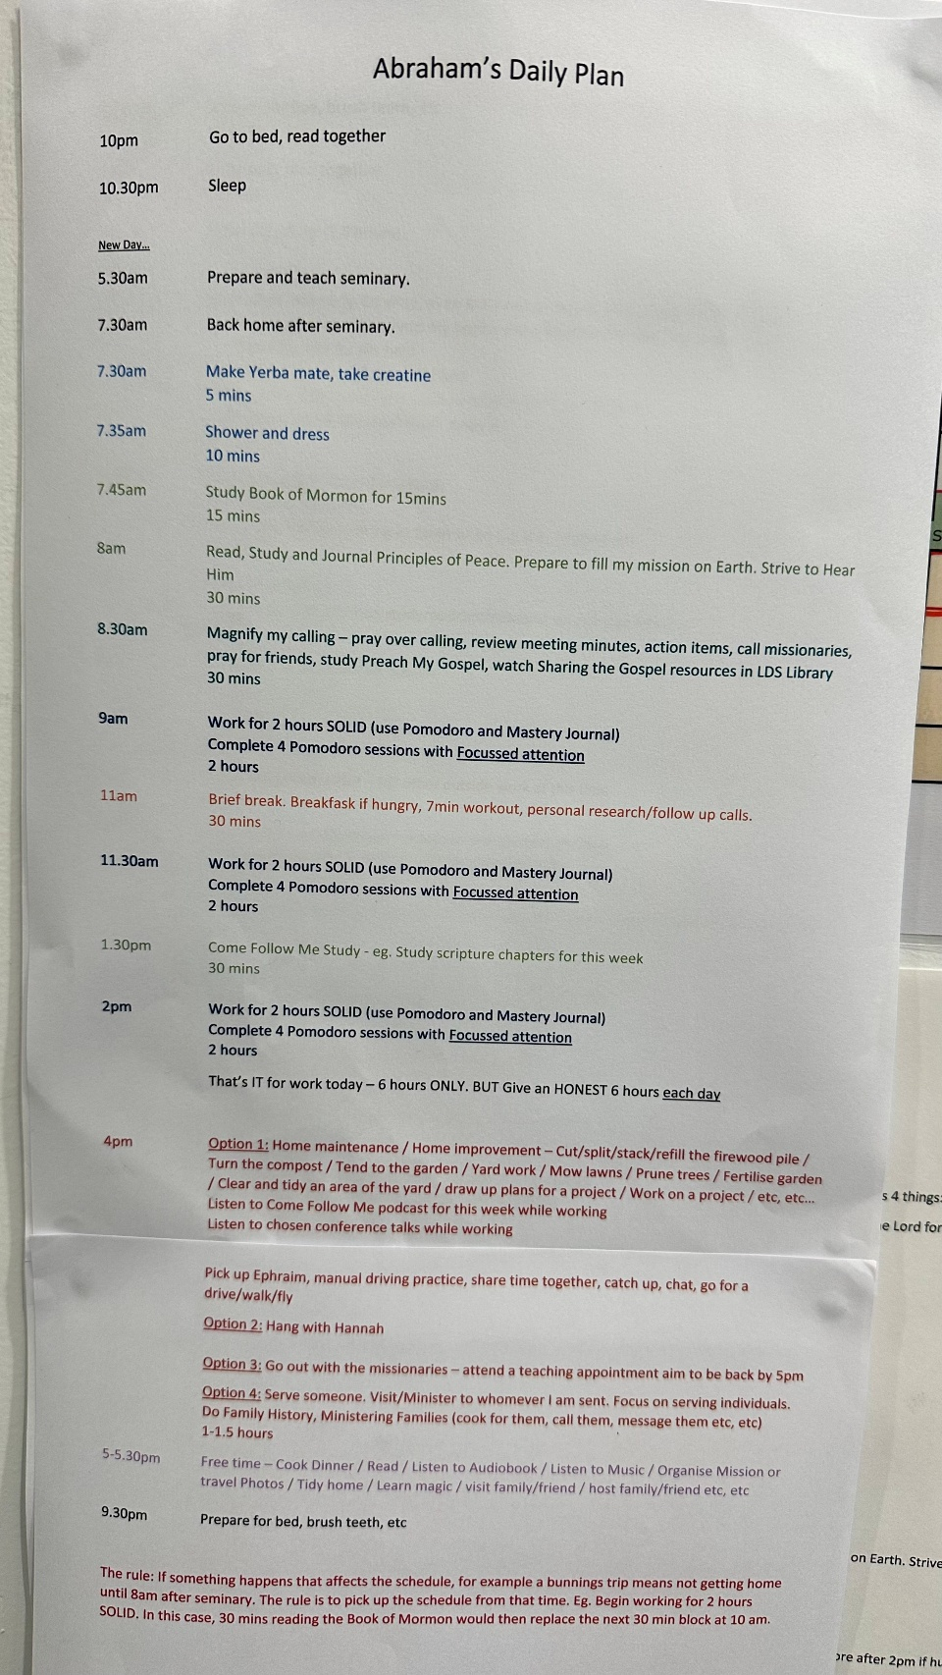
ChatGPT: Yes. Looking at your routine, I think what you need is not really a normal to-do list. You need a visual timeline that tells you where you should be right now, what you should be doing, and what comes next.
🥇 My pick for you: Structured
Structured — Daily Planner
I think Structured is almost tailor-made for the sheet you've created.
Its main screen is a vertical timeline of your day, with each activity occupying its actual time slot. You can see the current activity, upcoming activities and how much time is allocated to each one.
For example, your morning could look roughly like:
5:30 — Prepare & teach seminary
7:30 — Yerba mate + creatine
7:35 — Shower & dress
7:45 — Book of Mormon
8:00 — Principles of Peace / scripture study
8:30 — Magnify my calling
9:00 — 🔵 WORK — 2 HOURS
11:00 — Break / breakfast / workout
11:30 — 🔵 WORK — 2 HOURS
1:30 — Come Follow Me
2:00 — 🔵 WORK — 2 HOURS
And as you go through the day, you simply check things off and the timeline makes it obvious where you are.
The feature I think you'll particularly like
Structured has a Timeline Widget that can show your currently running task and upcoming tasks on your iPhone Home Screen. So you could potentially unlock your phone and see:
NOW: Work — 1h 12m remaining
NEXT: Come Follow Me — 1:30pm
THEN: Work — 2:00pm
without even opening the app.
It also supports Live Activities/Dynamic Island, including a focus timer showing your progress while your phone is locked.
That sounds particularly well suited to the way you've structured your work into 2-hour blocks and Pomodoro sessions.
And your routine can repeat automatically
Your morning routine doesn't need to be entered every day. Structured supports recurring tasks, including daily and weekly schedules. Recurring tasks currently require Structured Pro, though.
The free version is actually quite capable — timeline tasks, subtasks, notes, icons etc. are available without Pro.
Pro also adds things such as recurring tasks, custom notifications, calendar integration and AI scheduling. The current US pricing is $6.99/month, $29.99/year or $99.99 lifetime; Australian pricing will be shown in your App Store.
🥈 The other one I'd consider: Tiimo
Tiimo
Tiimo is more heavily focused on routines, visual timers and staying on task. It also has a visual timeline, widgets, Live Activities and Dynamic Island support.
I'd choose Tiimo if your biggest problem was getting yourself to start/switch between tasks.
I'd choose Structured for you because your existing paper plan is already fundamentally a time-blocked daily schedule. Structured is basically the digital version of what you've built on that sheet.

In fact, I think we can make this MUCH better than simply copying the sheet
If you install Structured, I can take the routine in your photo and help you turn it into a really clean setup — including:
- your 5:30am seminary routine
- the morning spiritual study
- your three 2-hour work blocks
- the Pomodoro structure
- your 11am break
- Come Follow Me
- your 4pm flexible family/house/church block
- your evening routine
- recurring days
- sensible colours/icons
- notifications so you're prompted when it's time to move on
- and a Home Screen widget showing NOW + NEXT
I would also not enter every little sentence from your paper as a separate task. I'd structure it so the app remains useful rather than becoming another thing you have to manage.
If you want, I can walk you through setting up Structured on your iPhone, step by step, using this exact routine.

ME: I want to have claude code build me an app that will do these key things that structured does: essentially allow me to create a custom daily plan. I have previously attached a photo of an example of my current daily plan. This should be a web app that I can install on my iphone. I want it to be nice and intuitive to use, but also I want it built and useable soon. Please give me a suggested prompt.

ChatGPT: Yes. I think the best approach is to give Claude Code a prompt that is very clear about the core job of the app, but deliberately limits Version 1 so it doesn't disappear down a rabbit hole building a full Structured competitor.
Your key idea is excellent: a personalised visual daily plan that always answers:
Where should I be right now? What am I doing next?
I would call the app something like DayPlan, My Day, or perhaps Steward Daily if you eventually want to connect it to your existing Steward ecosystem.
Here is the prompt I suggest giving Claude Code:

Prompt for Claude Code
I want you to build a simple, polished web application that I can install on my iPhone as a Progressive Web App (PWA).
The purpose of the app is to help me follow a personalised daily routine and always quickly see:
- What I should be doing right now
- How much time is remaining in the current activity
- What is coming up next
- Where I am in my overall day
The inspiration is apps such as Structured, but I do NOT want to recreate Structured or build a complex productivity system. I want a focused, fast and intuitive personal daily-plan app.
Important development approach
Please prioritise:
- A working MVP quickly
- Clean architecture
- Excellent mobile usability
- Simple and intuitive interaction
- iPhone-first design
- Avoiding unnecessary features
Do not over-engineer this project.
Before making major architectural decisions, inspect the existing project/repository and preserve anything useful. Explain briefly what you are going to build, then implement the MVP.

Core concept
The app should allow a user to create a custom daily plan consisting of time-based activities.
The main screen should visually show the day as a vertical timeline.
For example:
- 5:30am — Prepare and teach seminary
- 7:30am — Make Yerba mate and take creatine
- 7:35am — Shower and dress
- 7:45am — Study Book of Mormon
- 8:00am — Principles of Peace study
- 8:30am — Magnify my calling
- 9:00am — Work — SOLID
- 11:00am — Break
- 11:30am — Work — SOLID
- 1:30pm — Come Follow Me
- 2:00pm — Work — SOLID
- 4:00pm — Flexible afternoon activities
- Evening activities
- 10:00pm — Go to bed/read together
- 10:30pm — Sleep
The attached image shows an example of my current daily plan. Use it as inspiration for understanding the type of schedule and information I want to support.

THE MOST IMPORTANT SCREEN
The default/home screen should be the Today screen.
This should immediately answer:
NOW
Clearly display the current activity.
For example:
NOW
🔵 Work — SOLID
9:00am – 11:00am
1h 12m remaining
This should be visually prominent.
Show a clear visual indication of progress through the activity.
Possible approach:
- Progress bar
- Circular progress indicator
- Or subtle visual countdown
Do not make it overly flashy.

UP NEXT
Immediately below the current activity, show:
UP NEXT
Break
11:00am – 11:30am
In 1h 12m
Then show the next few upcoming activities.

DAILY TIMELINE
Below the NOW section, show a clean vertical timeline of the day's activities.
Requirements:
- Time displayed clearly on the left
- Activity name clearly visible
- Duration or end time visible
- Current activity clearly highlighted
- Completed activities visually subdued
- Future activities clearly visible
- The user should be able to scroll through the whole day
The app should automatically scroll or provide an easy way to jump to the current time.
There should be a clear visual marker showing:
NOW
on the timeline.
The experience should feel calm and simple, rather than like a complicated task-management application.

IMPORTANT: FLEXIBILITY WHEN THE DAY DOES NOT GO TO PLAN
One important principle of my current routine is this:
If something happens that affects the schedule, I pick up the schedule from the current point.
For example, if I am unexpectedly delayed in the morning and don't get home until 8:00am instead of 7:30am, I want to be able to simply continue from where I am.
I do NOT necessarily want the entire schedule to rigidly punish me or make me feel permanently "behind".
For Version 1, implement a simple concept of:
"Start from here"
The user should be able to tap an activity and choose something like:
Start this now
When this happens:
- That activity becomes the current activity.
- The app should treat the plan as continuing from this point.
- Future activities should shift forward appropriately based on their durations.
Please think carefully about this interaction and keep it simple.
However, if this feature becomes too complex for the initial MVP, implement the architecture to support it, but prioritise getting the normal fixed schedule working first.

COMPLETING ACTIVITIES
The user should be able to mark an activity as complete.
For example:
✓ Make Yerba mate
✓ Shower and dress
✓ Study Book of Mormon
Completed activities should visually change but remain visible.
However, this is primarily a schedule-following app, not a traditional to-do list.
The schedule and time should remain the central concept.

DAILY PLAN EDITING
The user needs a simple way to edit their daily plan.
Create a separate:
Edit Plan screen
The user should be able to:
- Add an activity
- Edit an activity
- Delete an activity
- Change the start time
- Change the duration
- Change the title
- Add an optional description or notes
- Reorder activities
Each activity should have:
Title
Start time
Duration
Optional notes
Optional category
For Version 1, the plan can simply be a single daily plan that repeats every day.
Do not build complicated calendar functionality yet.

CATEGORIES
Allow optional categories primarily for visual organisation.
For example:
- Spiritual
- Work
- Health
- Family
- Home
- Personal
- Free time
However, categories should remain lightweight.
Use subtle colours or icons.
Do not make the interface look like a rainbow.
The user should also be able to have no category.

SPECIAL ACTIVITY TYPES
Some activities in my schedule are flexible.
For example, my 4:00pm block might contain several possible activities:
- Home maintenance
- Gardening
- Pick up Ephraim / driving practice
- Spend time with family
- Meet with missionaries
- Serve someone
- Free time
For Version 1, support an optional activity type called:
Flexible Block
A Flexible Block can contain:
- A title
- A duration
- Several optional activities or notes
For example:
4:00pm — Afternoon
Choose one:
• Home maintenance
• Gardening
• Family time
• Missionary appointment
• Serve someone
The user should be able to select one of these options if desired.
Keep this feature simple.

IPHONE-FIRST DESIGN
This app will primarily be used on my iPhone.
The interface should therefore:
- Be optimised for mobile portrait orientation
- Have large touch targets
- Be readable at a glance
- Avoid tiny controls
- Avoid dense tables
- Avoid requiring lots of typing
- Feel good as an installed web app
The design should feel native to iPhone even though it is a web application.
Use:
- Clean typography
- Generous spacing
- Subtle rounded cards where appropriate
- A calm visual hierarchy
- Light and dark mode support if reasonably straightforward
Do not copy Apple's interface exactly, but aim for a clean, modern, calm aesthetic.

PWA REQUIREMENTS
This must be installable on an iPhone.
Please configure the application as a Progressive Web App.
It should include:
- Web app manifest
- App name
- App icon
- Apple touch icon
- Standalone display mode
- Mobile viewport configuration
- Offline support for the core app
Once installed on an iPhone, it should feel as close as practical to a normal app.

DATA STORAGE
For the initial MVP:
Use simple local persistence.
The user's daily plan should survive:
- Closing the browser
- Refreshing the page
- Restarting the phone
Do not require login or accounts for Version 1.
Prefer a simple and robust approach such as localStorage or IndexedDB.
However, structure the data layer so cloud synchronisation could be added later.

SAMPLE PLAN
Please create the following initial plan based on my current routine:
Morning
5:30am
Prepare and teach seminary
7:30am
Make Yerba mate and take creatine
Duration: 5 minutes
7:35am
Shower and dress
Duration: 10 minutes
7:45am
Study Book of Mormon
Duration: 15 minutes
8:00am
Read, study and journal Principles of Peace. Prepare to fulfil my mission on Earth. Strive to hear Him.
Duration: 30 minutes
8:30am
Magnify my calling
Notes may include:
- Pray over calling
- Review meeting minutes
- Review action items
- Call missionaries
- Pray for friends
- Study Preach My Gospel
- Watch Sharing the Gospel resources
Duration: 30 minutes

Work
9:00am
Work — SOLID
Duration: 2 hours
Notes:
- Use Pomodoro
- Use Mastery Journal
- Complete 4 Pomodoro sessions
- Focused attention
11:00am
Break
Duration: 30 minutes
Possible activities:
- Breakfast if hungry
- Short workout
- Personal research
- Follow-up calls
11:30am
Work — SOLID
Duration: 2 hours
1:30pm
Come Follow Me Study
Duration: 30 minutes
2:00pm
Work — SOLID
Duration: 2 hours

Afternoon
4:00pm
Flexible Afternoon Block.
Possible activities:
- Home maintenance
- Home improvement
- Firewood
- Gardening
- Mowing
- Pruning
- Fertilising
- Yard work
- Family time
- Pick up Ephraim / driving practice
- Time with Hannah
- Missionary appointment
- Serve someone
- Family history
The duration may vary.

Evening
5:00pm–5:30pm onwards
Free time.
Possible activities:
- Cook dinner
- Read
- Listen to audiobook
- Listen to music
- Organise mission or travel photos
- Learn magic
- Visit family or friends
- Host family or friends
9:30pm
Prepare for bed
Brush teeth etc.
10:00pm
Go to bed and read together
10:30pm
Sleep

VERSION 1 SCOPE
For the first working version, prioritise only these things:
Must have
- Beautiful Today screen
- Current activity clearly displayed
- Countdown/progress through current activity
- Up Next section
- Scrollable daily timeline
- Current-time indicator
- Mark activities complete
- Edit the daily plan
- Local persistence
- Installable PWA
Nice to have if straightforward
- Start activity now / resume schedule from here
- Flexible activity blocks
- Categories
- Dark mode
Do NOT build yet
- User accounts
- Social features
- Collaboration
- Complex calendar integration
- Multiple calendars
- AI scheduling
- Cloud sync
- Notifications
- Analytics
- Gamification
- Complex productivity metrics
We can add these later.

TECHNICAL EXPECTATIONS
Please:
- Use the existing project structure where appropriate.
- Keep components reasonably modular.
- Avoid unnecessary dependencies.
- Use a simple, maintainable data model.
- Ensure the app works well on mobile Safari.
- Make sure the app can be run locally during development.
- Test the core flows.
Before finishing, provide me with:
- A brief explanation of the architecture.
- Instructions for running the app.
- Instructions for testing it on my iPhone.
- A summary of what has been implemented.
- Any sensible suggestions for Version 2.
Most importantly: do not keep expanding the scope. Build the MVP and get it working.

One recommendation before you give this to Claude Code
I would build the first version as a separate app from Steward rather than putting it into your budgeting app. The two have very different purposes, and keeping this one small will dramatically increase the chance that you have something useful running quickly.
Once Claude has built the first version, I think the next step should be not adding more features. We should first look at the actual app on your phone and refine the main "NOW / UP NEXT / timeline" experience until it feels genuinely useful.
I can also help you with the next Claude Code prompt after the initial build, based on screenshots of what Claude produces.

